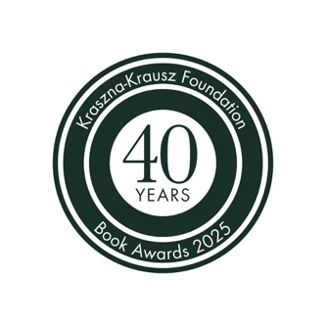

Kraszna-Krausz Book Awards 2026 Entry Form

Thank you for your interest in the 2026 Kraszna-Krausz Book Awards.
To submit a title, you are required to:

- Complete this entry form
- Send a sample pdf of or from the book
- Send at least 5 high resolution jpeg images from the book (at least 300 dpi, not photographs or pdfs of page spreads)
- Send a high res jpg, tif or pdf of the cover design

These items must be sent to info@kraszna-krausz.org.uk with ‘2026 Awards’ as the subject line.
Larger files can be sent via wetransfer with the book title and publisher included in the link information box.
The deadline for submission of books is Saturday 31 January 2026.

Eligibility will be confirmed by email and if approved, three hard copies of the book will be requested to be sent (one copy for each of the three judges). Postal addresses will be confirmed upon completion of this form.

If longlisted, an additional two copies will be requested for press, promotion and exhibition.
No copies of books submitted can be returned.

You may submit up to six different titles. An individual artist/editor/writer may submit their title separately if their publisher has already used their allotted six entries.

Please ensure that all sections of the form are completed.

Thank you, ctd. Overleaf
Submitter Agreement

Name of Publishing imprint:
[or write ‘self-published’]
Contact name & position:
Email address of contact:
Publisher/submitter website:
Publisher/submitter social media handles:
Address:
Country:
If not a UK publisher, please give name and address of UK distributor or stockist/s (this can include web addresses):
Where did you hear about the awards?
Submission checklist |  | - This completed form  - A sample pdf of or from the book  - 5 or more high res jpeg/tif images from the book (at least 300 dpi)  - A high res jpg, tif or pdf of the cover design (at least 300 dpi)
I submit the title(s) listed below for the 2026 Kraszna-Krausz Book Awards.
I have read and agree to abide by the Terms and Conditions for entry to the awards.
Signature: |  |  | Date:
Title/s to submit for the Kraszna-Krausz Photography/Moving Image Book Awards 2026*
Author/s, Artist/s or Editor/s | Title |  |  | Publication Date (month/year) | Photography or Moving image category? | Author/Artist website  (if relevant) | Author/Artist social media handles  (if relevant)

* Please complete on a separate sheet if more space is required

Enquiries

All enquiries concerning the Kraszna-Krausz Book Awards should be directed to: Alex Anthony, Kraszna-Krausz Foundation:
info@kraszna-krausz.org.uk
For further information, please visit the Kraszna-Krausz website:
www.kraszna-krausz.org.uk

